 CHEMICAL ENGINEERING TRANSACTIONS  VOL. xxx, 2026 | A publication of  
The Italian Association
of Chemical Engineering
Online at www.cetjournal.it

Guest Editors: Leonardo Tognotti, Rubens Maciel Filho, Viatcheslav Kafarov
Copyright © 2026, AIDIC Servizi S.r.l.
ISBN 979-12-81206-xx-x; ISSN 2283-9216

Recovery of Potassium and Phosphorus from Digested Sludge Ash via Selective Multi-Step Leaching
Domenico Rosa*, Martina Fazi
Department of Chemical Engineering Materials Environment, Sapienza-University of Rome, Via Eudossiana 18, 00184, Rome, Italy
domenico.rosa@uniroma1.it
Digested sludge represents a waste biomass derived from anaerobic digestion processes that require proper management due to its harmful pathogen content. The most common management route is incineration, which allows a reduction in volume. Within a circular economy framework, the valorization of these sludges is essential, considering that they are a suitable source of potassium (K) and phosphorus (P), essential macronutrients for agriculture.
In this study, a process for P and K recovery was developed based on a multi-step leaching approach applied to ash produced from co-combustion with NaCl. The ash was characterized to assess compositional variations induced by NaCl addition. The first selective leaching step was performed to extract K, followed by a second leaching step targeting P recovery. Different leaching systems based on H₂SO₄/citric acid mixtures were investigated. After optimization of the leaching conditions, an EDTA-assisted precipitation step was applied for P recovery.
NaCl addition promoted heavy metal volatilization and enhanced P extraction. Water-based leaching was selective for K, whereas the use of H₂SO₄ combined with citric acid was detrimental due to the co-extraction of heavy metals. The EDTA-assisted precipitation step limited heavy metal co-precipitation, yielding a P-based product compliant with the EU Regulation 2019/1009.
  - Introduction
Phosphorus (P) is an essential agricultural resource and a critical raw material for the European Union (EU) due to the high risk associated with its supply chain, which requires the development of alternative and sustainable recovery strategies. Among the different sources, digested sludge can be considered a suitable P source, as the ash produced by its combustion is generally rich in P (Volpe et al., 2020). Coupling P recovery with a waste valorization process could represent a valid alternative to conventional approaches; however, several issues still limit this strategy. Sludge ash is often rich in heavy metals (HMs), such as Ni, Pb, Cd, Zn, and Cu, which can compromise P recovery due to concentrations exceeding the threshold limits for agricultural use.
Several authors have attempted to recover P from this type of biomass, often failing due to the excessive HM content in the final product (Boniardi et al., 2021), as they did not consider the system as a whole. Indeed, given the strict limits, each step of the process must be properly optimized in relation to the subsequent steps, as they are strongly interconnected. For example, the incineration temperature is of crucial importance since it determines P speciation: as temperature increases, the conversion of phosphorus from non-apatitic (NAIP), mainly associated with Al and Fe and difficult to leach in acid, to apatite (AIP), associated with Ca and Mg and more easily soluble in acidic conditions, is enhanced.
Therefore, this study developed a process for secondary biomass valorization (such as digested sludge), enabling the recovery of key agricultural macronutrients, including potassium (K) and P. A multi-step leaching process applied to digested sludge ash (combusted at 850 °C, considered by many as the optimal temperature (Luyckx and Van Caneghem, 2021), since higher temperatures may lead to P volatilization, and co-combusted with NaCl, able to increase AIP solubility and improve HM volatilization), followed by EDTA-assisted chemical precipitation, was proposed. This approach successfully produces a P-based fertilizer that complies with EU Regulation 2019/1009.
  - Materials and Methods
Digested sludge derived from a livestock farm was collected downstream of a filter-press unit designed to separate coarse fibrous fractions and reduce moisture content (up to 90%).
The digested sludge was dried in an oven and ground using a mortar and pestle, then either left untreated or amended with 6 wt% NaCl (99%, Riedel-de Haën) and incinerated in a muffle furnace at 850 °C for 1 h under static atmosphere. The resulting ashes were labeled “blank” and “6%NaCl”, respectively.
A first leaching step was performed by treating the ashes with demineralized water (23 µS/cm) at different liquid-to-solid ratios (L/S) between 5 and 100 mL/g in separate batch experiments, for 1 h under continuous stirring at 500 rpm. The aim was to leach highly soluble potassium species (K⁺). The ashes were then filtered to separate the aqueous leachate, and the treated ash was dried and weighed.
A second leaching step, targeting P extraction, was carried out using 1 M H₂SO₄ (98%, Carlo Erba) at L/S = 10, combined with different citric acid (Carlo Erba) dosages (0-1.76 g/L) in separate batch experiments to facilitate acid leaching. The mixture was stirred for 1 h at 500 rpm. The leachate was then separated from the spent ash by filtration (2-3 µm cellulose filter).
For the precipitation step, EDTA (C₁₀H₁₄N₂Na₂O₈∙2H₂O, Carlo Erba) was first added to the leachate to reach a concentration of 0.8 g/L (based on preliminary optimization experiments), followed by the addition of Ca(OH)₂ (99%, Carlo Erba) to obtain a Ca/P molar ratio of 2.0. A 6 M NaOH solution was then added dropwise to adjust the pH up to 10. The process was controlled based on molar ratios and pH. Precipitation was carried out at 30 °C for 24 h under continuous stirring (500 rpm).
The precipitate was filtered, washed, and dried to obtain the final product (P-based fertilizer).
Blank, 6%NaCl, and the P-based fertilizer were characterized after acid digestion to determine HM, K, and P content. Aqua regia digestion (liquid-to-solid ratio 100 mL:1 g) was performed using a microwave-assisted system for 2 h. Scanning Electron Microscopy-Energy Dispersive X-ray Spectroscopy (SEM-EDS) analyses were also carried out to evaluate elemental composition and morphology, as in a previous study (Rosa et al., 2025).
HMs and K were quantified by atomic absorption spectroscopy (AAS) using an Agilent instrument, while dissolved P (as phosphate) was determined using the molybdenum blue method (Murphy and Riley, 1958) with a PG Instruments T80+ UV/Vis spectrophotometer in all liquid streams produced during the process.
  - Results and Discussion
    - Ash characterization
Ash characterization results are shown in Figure 1.
P₂O₅

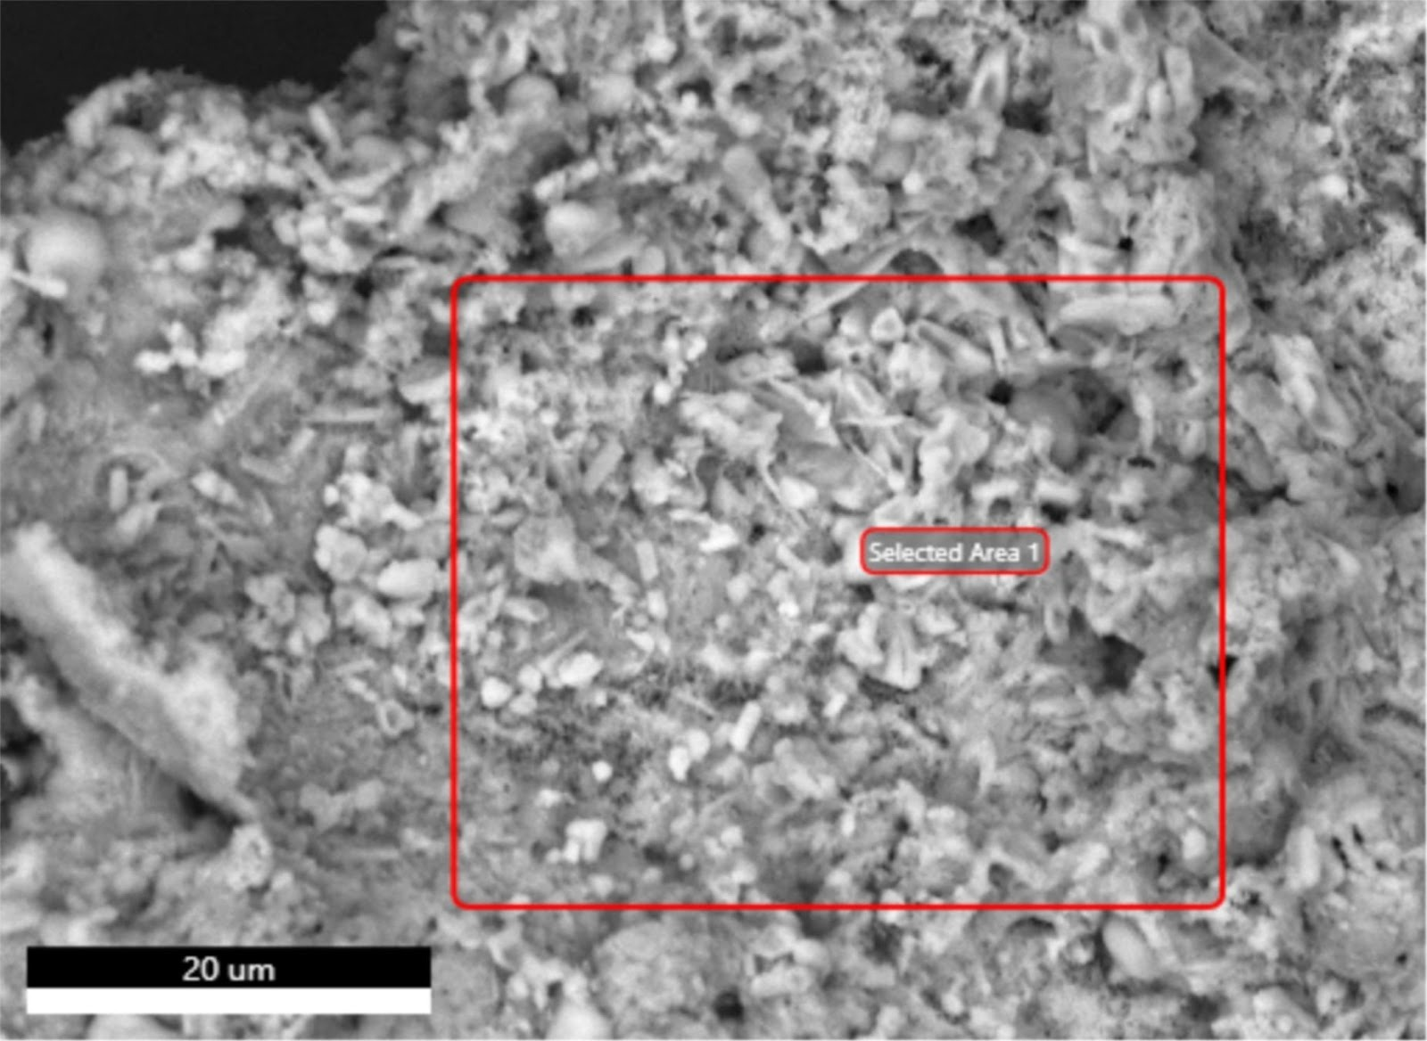
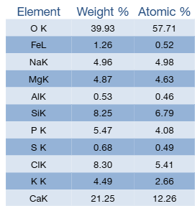
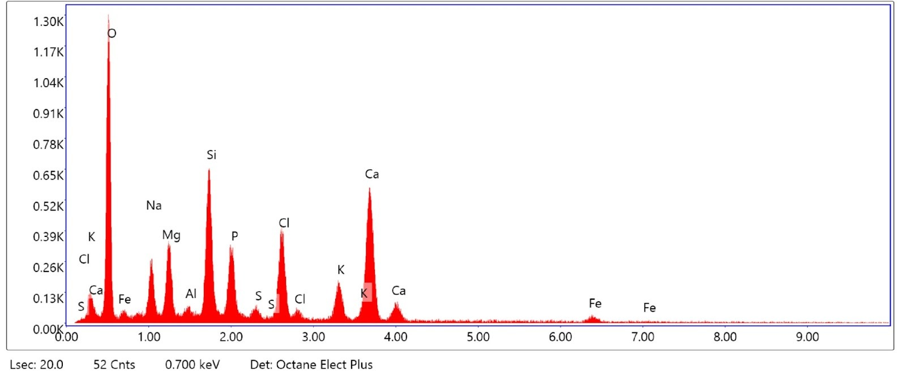
c)
Figure 1: a) Macronutrients and b) HMs amount in blank, and 6%NaCl ashes. c) SEM image of 6%NaCl ash and EDS analysis.
Blank ash composition showed suitable P and K contents; in fact, P₂O₅ and K contents were 188 and 143 g/kg, respectively (Figure 1a). Furthermore, HMs exceeded threshold limits for several elements, including Ni, Pb, and Cu, with concentrations of 127, 710, and 993 mg/kg, respectively (Figure 1b). Zn and Cd were found to comply with EU Regulation 1009/2019, with concentrations of 971 and 24 mg/kg, respectively.
In 6%NaCl ash, a significant HM depletion was observed due to HM volatilization as chloride compounds. In fact, NaCl could act as a chloride donor, drastically reducing HM content (Saleh Bairq et al., 2018). The HMs most affected by NaCl addition were Pb and Cd, whose contents were 120 and 6 mg/kg, respectively.
Zn and Cu also showed a significant depletion, reaching contents of 424 and 238 mg/kg, respectively. Ni was less affected by NaCl addition, and its content was still too high (75 mg/kg).
NaCl addition did not influence the P₂O₅ and K contents, which remained constant during the treatment.
SEM analysis (Figure 1c) showed a particle morphology divided into two main fractions: one with a smooth surface and the other consisting of smaller particles. EDS analysis detected a high Ca content (21.3%) and low amounts of Fe (1.3%) and Al (0.5%), indicating that P could be mainly present as AIP rather than NAIP. This suggests that acid leaching could be a suitable process for P solubilization (Boniardi et al., 2024).
    - Leaching
Results of the first leaching (H₂O-based leaching) are reported in Figure 2.

Figure 2: H₂O-based leaching on 6%NaCl ash: a) K extracted (expressed as g of K⁺/kg of ash) and b) HMs extracted (expressed as mg/L) at varying L/S ratios.
H₂O-based leaching extracted approximately 100 g of K⁺ per 1 kg of 6%NaCl ash (Figure 2a), resulting in a concentration of ~20 g/L K⁺ at L/S = 5. In fact, K extraction was not affected by the L/S ratio in the explored range between L/S 5 and 100, so the lowest amount of H₂O is more advantageous because it results in a production of a more concentrated K solution.
Furthermore, HMs content in the leachate was at very low concentrations. Ni²⁺ and Cr³⁺ were not detected, indicating that they are present in the ash as non-soluble salts. At L/S = 5, only Zn²⁺ and Pb²⁺ were detected, at concentrations of 2 and 3 mg/L, respectively (Figure 2b).
Although these amounts cannot be neglected, they comply with threshold limits for K-based fertilizers because, using a conservative estimate of the dry residue consisting exclusively of KCl and thus assuming 20 g/L of K⁺, about 38 g/L of KCl is expected (actually, the dry residue is higher since other ions are also present), the theoretical Pb is 79 mg/kg, lower than the threshold limit of 120 mg/kg of EU Regulation 2019/1009. Zn has higher limits (1500 mg/kg) since it is a micronutrient.
However, this solution cannot be classified as a liquid inorganic K-based fertilizer because it should contain K₂O m/m > 3%, whereas the present solution has an equivalent K₂O of about 2.5%. Therefore, less H₂O should be used, or further concentration steps (such as crystallization) should be considered.
Acidic leaching (H₂SO₄-based leaching) results are shown in Figure 3.

Figure 3: a) Extraction percentages at varying citric acid concentrations using 1 M H₂SO₄ (L/S = 10) on blank ash. b) HMs concentration in the leachate obtained from blank and 6%NaCl ash treated with 1 M H₂SO₄ (L/S = 10).
Acid leaching carried out with 1 M H₂SO₄ extracted 76% of P and a moderate amount of Cu²⁺ and Pb²⁺ (approximately 27%). Cr³⁺ and Cd²⁺ were not detected, indicating that H₂SO₄ is relatively selective and ensures a low content of these HMs, allowing an adequate separation of P. Zn²⁺ and Ni²⁺ were the most extracted HMs, reaching extraction percentages around 50% (Figure 3a).
Increasing citric acid concentration enhanced the extraction yield of all compounds; for P, about 85% was achieved (0.44 g/L of citric acid). However, the increase in extraction was detrimental due to the co-extraction of HMs. These results demonstrate that a mixture of H₂SO₄ and citric acid is a stronger leachant but less selective; therefore, for this purpose, it is not an adequate strategy. Thus, the best leachant resulted in H₂SO₄ alone, considering its higher selectivity for P.
Leaching carried out on 6%NaCl ash demonstrated that NaCl enhanced P extraction (from 76 up to 91%), converting AIP into more soluble species as NaCaPO₄ (rhenanite) (Bier‐Schorr et al., 2025), while simultaneously reducing the HM content in the leachate (Figure 3b), making this approach the most suitable and thus selected for the precipitation step. In fact, in the leachate from 6%NaCl ash, PO₄^{3–} ions reached a concentration of 24.4 g/L, while Pb²⁺, Zn²⁺, and Cu²⁺ concentrations significantly decreased. Ni²⁺ was less affected, maintaining a nearly constant concentration (~4.5 mg/L). Although the HMs were present in lower amounts due to NaCl-induced volatilization, they appeared more mobilized and easily leachable, partially counteracting this advantage. In any case, the overall effect was positive; however, attention should still be paid to Ni due to its relatively high concentration.
Cd²⁺ and Cr³⁺ were not detected in the leachate from 6%NaCl ash.
    - Precipitation
Preliminary tests were carried out evaluating P % precipitated at varying Ca/P molar ratios, and results are shown in Figure 4a.

Figure 4: a) P precipitation yields (%) at varying Ca/P molar ratio after 24 h at 30 °C and pH 10. b) HMs concentration in the supernatant post precipitation (Ca/P = 2, EDTA 0.8 g/L); Cd and Cr resulted <LOD.
The precipitation percentage increased with increasing Ca/P ratio until reaching a plateau. At a Ca/P ratio of 1.5, precipitation was 86% and increased linearly to 97% at a Ca/P ratio of 2.0; above 2.2, precipitation yields exceeded 98%.
Ca(OH)₂ proved to be an effective precipitating agent, promoting the formation of AIP as Ca₃(PO₄)₂. Although the stoichiometric Ca/P ratio is 1.5, this condition resulted in an unsatisfactory precipitation yield. Literature reports an optimal Ca/P ratio of 1.67 for hydroxyapatite formation, typically with a slight excess of Ca (Yang et al., 2022). In this study, the optimal Ca/P ratio was identified as 2.0, achieving a precipitation percentage of 97%, which was considered acceptable; therefore, a subsequent EDTA (0.8 g/L)-assisted precipitation step was performed at Ca/P = 2 to avoid HMs precipitation (Figure 4b), especially for Ni²⁺. In fact, EDTA acts as a chelating agent for HMs.
The precipitate was subjected to acid digestion, and the results are shown in Table 1.
Table 1: P-based fertilizer and leachate composition.
 | P₂O₅ | Ni | Pb | Cu | Zn | Cd | Cr
Units | % | mg/kg | mg/kg | mg/kg | mg/kg | mg/kg | mg/kg
P-based fertilizer | 29.8 | 40.1 | 70.2 | 283.5 | 465.9 | 1.7 | 2.6
EU Regulation 1009/2019 | >5 | 50 | 120 | 600 | 1500 | 40 | n.a.

Results proved that a P-based fertilizer was successfully synthesized according to EU Regulation 1009/2019. In fact, all HMs resulted in concentrations lower than the threshold limits, and the P content (as P₂O₅) was 298 g/kg. EDTA effectively partially inhibited Ni²⁺ precipitation, highlighting the importance of a suitable dosage. If all the Ni²⁺ present in the leachate had precipitated, a theoretical content of approximately 80 mg/kg would have been obtained, exceeding the threshold limits. An experimental value of 40 mg/kg was observed, indicating that EDTA effectively prevented at least 50% of Ni²⁺ from precipitating.
SEM-EDS further confirmed the findings from the acid digestion step, as shown in Figure 5.

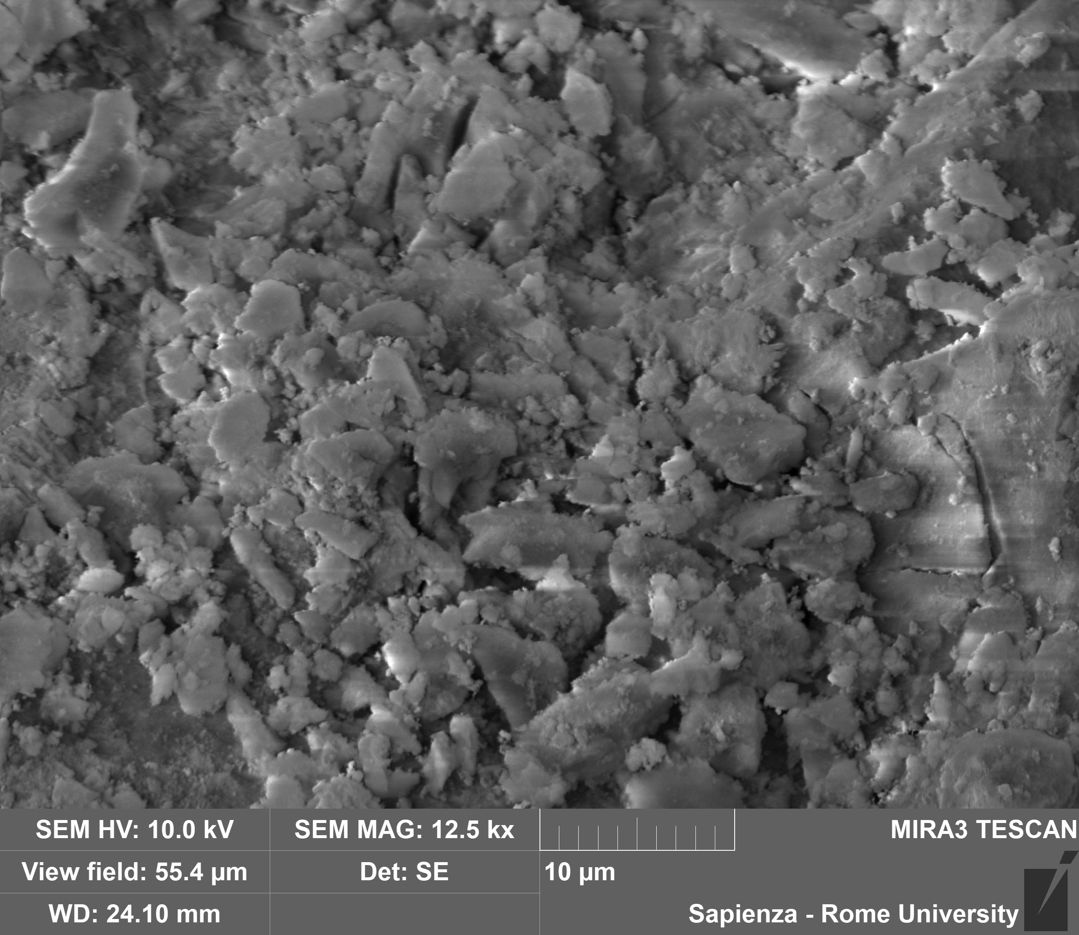
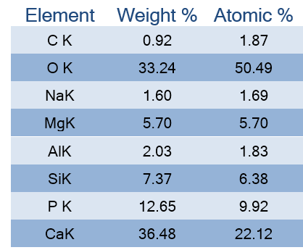
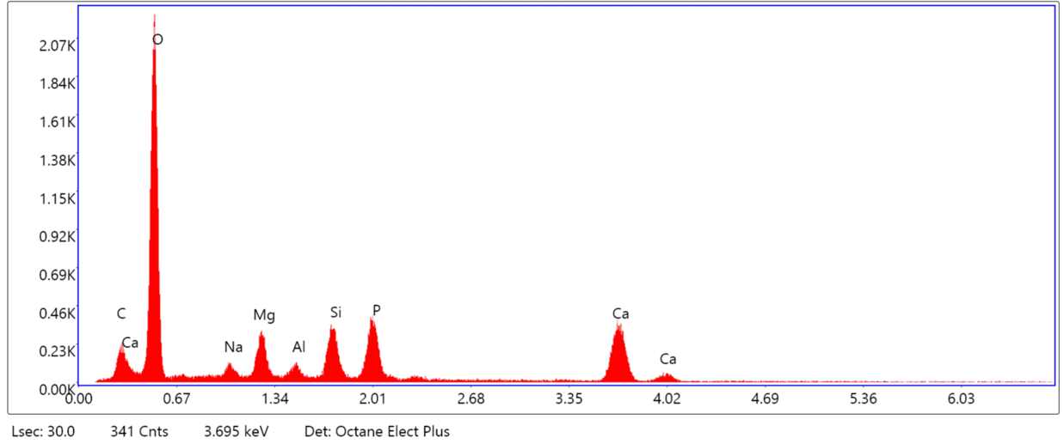
Figure 5: SEM-EDS analysis of the P-based fertilizer.
The precipitate was rich in Ca (36.5%) and P (12.7%), in agreement with Ca₃(PO₄)₂ compounds. Furthermore, EDS detected a P content of 12.7%, which corresponds to a P₂O₅ content of 29%, in agreement with the mineralization results. A significant amount of Mg was also detected (5.7%), indicating that the proposed process is also able to recover Mg, which is important for agricultural use and for the EU (as it is considered a critical raw material).
  - Conclusions
This study developed a process able to recover several nutrients from waste biomass such as digested sludge. Co-combustion of sludge with NaCl demonstrated a significant reduction in the HMs content (Ni, Pb, Zn, Cu, Cd, and Cr) while maintaining constant P and K amounts.
A multi-step leaching approach demonstrated the selective extraction of target species: H₂O-based leaching selectively and successfully extracted 100 g of K per kg of ash, due to the high solubility of K compounds.
H₂SO₄-based acid leaching demonstrated a P extraction of 76%, and NaCl addition enhanced extraction up to 91%, converting the main AlP phases into more soluble species such as NaCaPO₄. The effectiveness of the acid extraction was mainly due to the low concentrations of Fe and Al in the sludge and the high concentration of Ca, which made acid extraction suitable.
Furthermore, 1 M H₂SO₄ at L/S = 10 yielded poor extraction of HMs, indicating a significant advantage for HMs/P separation. Citric acid addition was detrimental for the leaching process because, although it increased P extraction, it also increased HMs extraction due to its stronger leaching capacity.
A precipitation step performed at Ca/P = 2 by adding Ca(OH)₂ at pH 10, assisted by EDTA (0.8 g/L), proved suitable to precipitate 97% of P while limiting the co-precipitation of HMs, which was partially hindered by the chelating effect of EDTA.
Overall, P recovery reached 89%, obtaining a P-based fertilizer containing 29.8% of P₂O₅ and 5.7% of Mg. From 1 kg of dry sludge, 0.250 kg of P-based fertilizer compliant with EU Regulation 1009/2019 for inorganic solid P-based fertilizers was produced.

Acknowledgments
This work was supported by the “Avvio alla Ricerca” program (Sapienza University of Rome, CALL-0672 - Bando per la Ricerca Scientifica 2025, CUP: B83C25004300005).
References
Bier‐Schorr L., Gräser V., Scherer‐Lorenzen M., Hajek P., Kurz P., 2025, Enhancement of the Plant‐Accessible Phosphate Fraction in Sewage Sludge Ashes by Na + or K + Addition Prior to Combustion, ChemSusChem 18.
Boniardi G., Close K., Turolla A., Canziani R., Oehmen A., 2024, Assessment of three different approaches for integrating phosphorus recovery from sewage sludge and derived products in existing wastewater treatment plants, Bioresource Technology, 402.
Boniardi G., Turolla A., Fiameni L., Gelmi E., Malpei F., Bontempi E., Canziani R., 2021, Assessment of a simple and replicable procedure for selective phosphorus recovery from sewage sludge ashes by wet chemical extraction and precipitation, Chemosphere, 285.
Luyckx L., Van Caneghem J., 2021, Recovery of phosphorus from sewage sludge ash: Influence of incineration temperature on ash mineralogy and related phosphorus and heavy metal extraction, Journal of Environmental Chemical Engineering, 9.
Murphy J., Riley J.P., 1958, A Single-Solution Method for the Determination of Soluble Phosphate in Sea Water, Journal of the Marine Biological Association of the United Kingdom, 37, 9–14.
Rosa D., Rizzo F., Di Palma L., 2025, Lime and pozzolan-based matrices for an efficient immobilization of hazardous waste, Chemical Engineering Science, 313.
Saleh Bairq Z.A., Li R., Li Y., Gao H., Sema T., Teng W., Kumar S., Liang Z., 2018, New advancement perspectives of chloride additives on enhanced heavy metals removal and phosphorus fixation during thermal processing of sewage sludge, Journal of Cleaner Production, 188, 185–194.
Volpe M., Fiori L., Merzari F., Messineo A., Andreottola G., 2020, Hydrothermal Carbonization as an Efficient Tool for Sewage Sludge Valorization and Phosphorous Recovery, Chemical Engineering Transaction, 80, 199–204.
Yang H., Kang J.-K., Park S.-J., Lee C.-G., 2022, Phosphorus recovery from cattle manure bottom ash by extraction and precipitation methods, Environmental Science and Pollution Research, 29, 39567–39577.

